Today’s Lecture Road Map
Dated: 30thApril 2021
Intent

An Intent is a message package that is used to request services/ information from other components in the Android system.

- Start an activity
- Start a service
- Manage broadcasts
- Navigate from one activity to other
- Intent filter (launching activity)
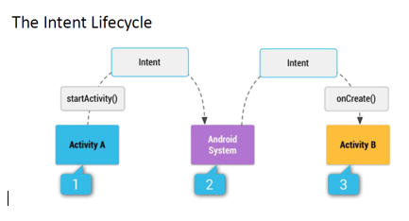
Explicit intent [From Act A -> TO Act B] Direct Addressing
An explicit Intent is one that is directly addressed to another component. The Intent itself uses the .class component of the class as it’s “addressing system”. Intents can operate like HTTP packets:
- They have a “to” and “from”
- They can contain data
- They can contain meta information

Activity From:
Intent myIntent = new intent (ActivityFrom, ActivityTo)
StartAvtivity(myIntent)
Activity To: getIntent() //how I started?
Implicit Intent [Action chooser generate (User Decide)]
An implicit Intent is broadcast to the entire system. Based on category / pattern matching, intent filters will pick all Activities that can respond. A chooser is then presented for the user to decide which Activity should respond to the Intent
- Action (SEND)
- Extra (TEXT)
- Type (String)

Toast
Toast is just a message that appears on the screen for a short period of time and then it disappears.
- Give user feedback regarding some operations.
- It does not block an activity or fragment.

